Empathy & Visual Elements in Textile Print Design for Consumer with specific needs
Abstract
Textile Print design is considered as a decorative means of value addition to textile materials. Printed textiles express cultural and personal identity in reference with time and space. Various brands come up with novel print ideas and emotive visual elements as per consumer requirements for diversified product range. However brands mostly cater to the needs of larger group of people with trend driven choices. Advancement of inkjet digital printing technology on textiles has created enormous possibility to address the issues related to personal expression and consumer with specific needs. This research paper refers empathy in visual elements explored by textile print designers to address the consumer with specific needs. This research explores the idea that an understanding of users needs is significant for a designer to bring effective solutions and value. Through this research paper researcher examines the explorations developed by mentoring two classroom design projects based on following consumer requirements.

- Exploring visual elements in printed textiles for Hospital room and waiting areas
- Exploring visual elements in printed textiles for Vegan’s personal dining collection
Above classroom projects were guided by researcher and the outcome of projects were examined and compiled as a research paper.
Key Words
Visual elements, print design, personal expression, specific needs, empathy

Introduction
Empathetic design discussion began in late 1990s alongside design thinking. The researchers Ulay Dandavate, Elizabeth Sanders and Susan Stuart discussed that user-centric design shall inculcate rational as well as emotional considerations for holistic outcome (Dandavate, U., Sanders, E. B. N., & Stuart, S., 1996).
Empathy is an effort to develop understanding of how others may feel or experience. Therefore empathy is cognitive and emotional both. (Candy Carmel Gilfilen, Margaret Portillo, 2015).

An empathy map is proposed by Sarah Gibbons in one her research papers. It discusses the collaborative visualization for articulation of individual user or user-group. This helps understanding of user needs and plays an important role in decision making.
- Single user empathy map can be derived by using personal interview or diary logs.
- Multiple-user empathy maps can be generated by interacting with larger groups having similar concerns and needs. Such maps are derived from summarizing needs and concerns of individuals (Sarah Gibbons 2018).

Purpose Research Question
The purpose of this research paper is to examine and discuss color and other visual design elements for print design through two case studies based on class room design projects carried out under the guidance of researcher.
The key query is to examine the designer’s approach and considerations while working on a design project for creating personalized visual identity. It also explores how a print conveys empathy through color and visual design elements therefore generates value for personalized use and specific needs. Role of inkjet digital printing technology is significant due to the capability of creating smaller runs and pre-engineered designs/patterns to fulfill specific design requirements.
It allows explorations of unconventional techniques over drawings. It also facilitates hand and digital medium combined for print conceptualization.
Empathy tools play important role in two stages of a design conceptualization and implementation. Initial research phase helps designers to understand the user perspective and needs. Second phase is prototype development and testing. It helps designer determine the outcome of design for users.

The material and visual landscape that surrounds us creates experience and impact our day to day lives. They have an effect on our efficiency, emotional wellbeing and social connectivity. A product designed with careful considerations enhances user experience and contributes to healthy environment (McDonagh D, Thomas J. 2010). Our identity is reflected through the products that surround us. It also creates an impact on how we experience our daily lives. We form rational as well as emotional connections with our material surrounded world. It communicates with us and also communicates to the world about our identity (Chapman J.2005).

Material landscape is a dynamic means for reflection as well as use. We often use symbolism in our surrounding/personal space such as product/s that reflects our achievements, belief or aspirations (Walker S.2006). These products and visual elements also provide emotional support and positive affirmation (Riggins SH. Fieldwork, 1994)

Based on the thought process of visual material landscape design brief for two class room projects was prepared. First case study is based on class room project where design student has explored visual elements for the hospital waiting area and patient’s room/suite. Second case study is based on a personalized class room project where student has explored visual design elements/prints for a vegan client to create a vegan visual identity for dining space or kitchen.
Methodology
In order to develop designs and products for people it is critical for designers to be able to develop active listening skills, engagement and interaction with users. It is also important to make the users a part of the designing process by feedback at different stages of design (Strickfaden M, Devlieger P, and Heylighen, 2009).

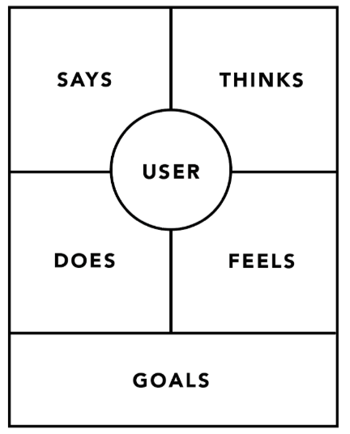

Fig1: Basic empathy map by Sarah Gibbons presenting the variants to determine user goals

Designers require visualizing the user attitude, behavior, need, and desire in order to map the variants for empathy for separate cases. It helps designer to develop relatively deep understanding of user that they may be otherwise unfamiliar with. The mapping helps designer to lay a foundation to start thinking. Therefore the above model by Sarah Gibbons was adapted for both case studies presented in this research paper.

Two Case studies by continuous mentoring of two student’s works in classroom environment was carried out in stage 1. Second stage involves analysis of students work, design selection and print development through discussion and brainstorming. Researcher collaborated with design students to create and implement design brief that caters to a specific group of people. A team of two students worked with the user group of six people per project. The study sets out to determine the considerations a designer makes while selecting design elements and color for personalized use and specific needs.
Visual References: Case Study 1
(Project: Sanat)
Tim Brown discusses in his book ‘Change by Design’ that health care environments can be improved by using empathy. Empathy helps the user connect holistically to the health care environment. (T. Brown, Change by Design, 2009)
Project “Sanat” (means healing or therapeutic) aims at creating a feeling of self healing, peace and relaxation. The mood is hope giving and positive. The purpose is to create distraction from pain and ailment. The color palette is refreshing and soothing as per chromo therapy. The query raised during the project enquires following; how do we seek hope in design elements. The possibilities were seen in natural elements coming together from different dimensions/space.
For example:
Tree + Clouds
Flowers + Birds
Petals + Waves
(The print collection is inspired by Cherry Blossom flower and its natural surroundings)
Approach to design development: The designer started the discussions with user group by discussing the following cues. For example:
- What do you miss most when you need to stay inside a hospital room for short or long duration?
- What provides you positive distraction?
Based on the responses to questions designer started to work with nature as core theme and explored few ideas and showed the sketches to the users for feedback.
The designer started with sketching and painting flowers, birds, clouds, waves separately. 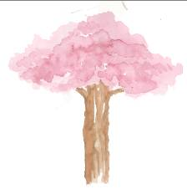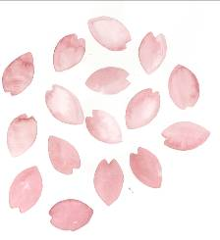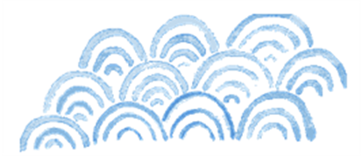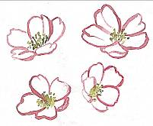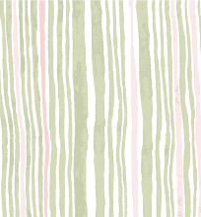
Fig2: Initial hand painted print explorations
Thereafter the combinations were explored as print concepts to bring elements from different dimensions together to bring element of hope in designs. Different elements were combined together to build synergy and fluid yet calm perceive value in print design.
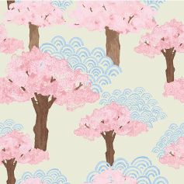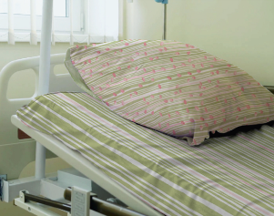
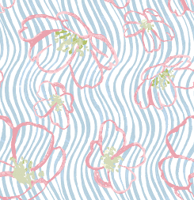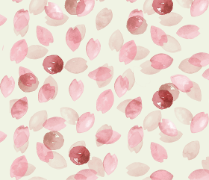
Fig 3: Prints explored in Digital Medium
Visual References: Case Study 2
(Project VEGAN)
Project “Vegan” (using or containing no animal products) aims at celebrating one of the biggest food trend VEGANISM through visual design for the vegans. The objective is to enhance their food experience by setting the vegan friendly dining space. The movement is being driven by young people making more ethical and compassionate choices. Recognized for its positive impact on sustainability and animal welfare without the need to sacrifice taste or style, vegan living is starting to become the norm.
- What elements do you associate with Veganism?
- What is special about being a Vegan?
The queries raised during the project questioned; Based on principles of Veganism a list of food items was prepared. The food items and ingredients were photographed by students to derive texture, motif and patterns. The scanned textures/images were edited in digital medium to create seamless print patterns.
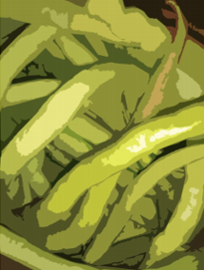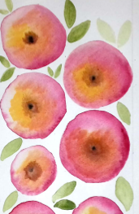
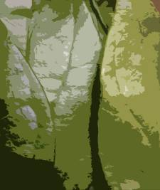
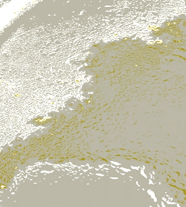
Patterns inspired from Chilies, Sliced Onions, Rice Flour and Spinach Leaves
Fig 4: Initial explorations using photography and scanning real surfaces
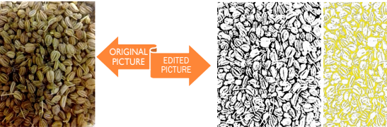
Carom Seeds inspired texture/pattern
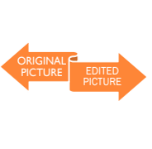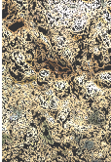
Baked Bread inspired texture/pattern
Fig5: Prints explored in Digital Medium (Combination of Photography and Digital editing techniques)
Evaluation
The prints were evaluated through a feedback process primarily focusing on design thinking as a model. In a design process, designer’s address and use empathy in different ways. Empathy can be considered as a tool to design – required changes in a design idea that incorporates emotional feeling as feature. As per Tim Brown: designers can use empathy to acquire insight into users’ needs as a part of the design process. Both case studies use second thought process recommended by Tim Brown’s definition of design thinking and use of empathy. The design concepts in both projects discussed above; user was consulted to form outline and draw design elements from it. The user group was small therefore a qualitative brainstorming took place to determine the design elements. Few interesting thought process could be derived from the brain storming session before and after project/s.

- Review of Case Study 1 (Project: Sanat)
- Familiar topics may be dealt in Non-familiar ways seem interesting as the objective of design is to create distraction.
- The distraction by print is only visual in nature therefore is limited to visual sensory.
- The visual perceptions differ as per age, time, space and experiences therefore this project represents a generic approach rather than specific.
- Different dimensions are combined together to create symbolism.
- Color palette needs to be a combination of different emotion conveyers/carriers (such as warmth + soothing).

- Review of Case Study 2(Project: Vegan)
- Familiar inspiration is useful as the objective of design is to create belongingness and reflect identity.
- Symbolism is portrayed through digital visual interpretation of real.
- Color palette needs to be close to real objects/inspiration to reflect identity in place of emotions.
- Being Vegan is a global phenomenon therefore the elements used in the project are universal in nature.
- However few elements could be used as per local preferences also depending on the location of users.
- Design elements used in Vegan project relates to visual sensory and can be enhanced with printing on textured surfaces to add tactile characteristics.

Discussion and Findings
The effort to address design coming together with empathy has been approached in a systematic manner. It may be considered that empathy leads to “good” and “meaningful” design. In both case studies the designer empathetically reviews and responds to the specific needs of the user (Kruger Runnet, 2008).

The designer usually uses sketching ideas for ideation as well as presentation differentiated as ‘bottom-up’ and ‘top-down’ approaches. The bottom-up method involves examining and working with a variety of design elements, having commonality and variations. Design establishes a conceptual ideation to abstract the idea based on specifics. The top-down design ideation tends to look at the smaller design elements as potential synthesizers for creation of a bigger idea (Ball and Ormerod, 1995; Cross, 2004; Guindon, 1990).
In regard to the ideation process, both processes have been used simultaneously to engage the designer as well as user throughout the design concept development. Results revealed that visual elements presenting empathy focuses on two aspects.
1. Color palette: Colors reflects energy and identity in the case studies discussed in this paper. Color palette forms a larger part of any visual design. A color palette selected with considerations reflects empathy in a subtle yet significant manner.
2. Visual Elements of textile design (motif, pattern, and layout) and its association with viewer’s perception: This is another aspect that forms empathy however this is yet to be explored in-depth using various projects as examples. In two case studies discussed in this research paper; motif and pattern deals with elements that could be applied to specific group of people for personalized use. Therefore it can be understood that more research is required while handling projects involving a larger user base.
The design elements also involve symbolism to build association between users and design/prints. Emotional connections made with the synergy of understanding color theory, its application and elements of design evokes sense of belongingness and print design establishes connection between consumers and their product. Use of digital printing on textiles has formed multi-dimensional aspects and emerging opportunities. Apart from aesthetics; digital textile prints successfully address specific requirements embedded with ‘Empathy” as potential feature.

References

Ball, L. J., & Ormerod, T. C. (1995). Struc tured and opportunistic processing in design: A critical discussion. International Journal of Human–Computer Studies , 43, 131–151.
Brown, T. (2009). Change by design: how design thinking transforms organizations and inspires innovation. New York, USA: Harper Business.
Candy Carmel Gilfilen, M. P. (2015 , July 13). Sage Publications. Retrieved December 12, 2018, from https://journals.sagepub.com/doi/abs/10.1177/1937586715592633
Chapman, J. (2005). Emotionally Durable Design: Objects, Experiences and Empathy. London: Earthscan.
Gibbons, S. (2018 , January). Empathy Mapping: The First Step in Design Thinking. Retrieved December 13, 2018, from https://www.nngroup.com/articles/empathy-mapping/
Guindon, R. (1990). Designing the design process: Exploiting opportunistic thoughts. Human–Computer Interaction. Human-Computer Interaction , 5, 305–344.
Hoss, J., Roopani, N., & Keene, C. (n.d.). Empathy Tools. Retrieved December 11, 2018, from Design Research Techniques: http://designresearchtechniques.com/casestudies/empathy-tools/Design
L. J. Ball, T. C. (1995). Structured and opportunistic processing in design: A critical discussion. International Journal of Human-Computer Studies , 135-151.
McDonagh, D., & Thomas, J. (2010). Rethinking Design Thinking: Empathy Supporting Innovation. Australasian Medical Journal - Health and Design 1 , 3 (8), 458-464.
Nigel, C. (2004). Expertise in design: An overview. Design Studies , 25, 427–442.
Portillo, C. C. ( 2015 , July 15). Retrieved Dec 12, 2018, from Sage Publications: https://journals.sagepub.com/doi/abs/10.1177/1937586715592633
Riggins, SH.Fieldwork (1994). “The Living Room” . In The Socialness of Things. New York: Mouton de Gruyter.
S. New, a. L. (2013). Chimps Designers, Consultants and Empathy: A “Theory of Mind” for Service Design . Cambridge Academic Design Management Conference. U.K.: Cambridge University.
Spencer, E. (1881). The principles of psychology. London, UK : Williams and Norgate.
Strickfaden, M., Devlieger, P., & Heylighen, A. (2009). Building empathy through dialogue In: Malins J .Design Connexity . Proceedings of the Eighth International Conference of the European Academy of Design (p. 451). Aberdeen: Scotland: Gray’s School of Art.
Walker, S. (2006). Sustainable By Design: Explorations in Theory and Practice. London: Earthscan.
List of Figures and Table
Figure 1:
Empathy Mapping: The First Step in Design Thinking by Sarah Gibbons on January 14, 2018, Retrieved from https://www.nngroup.com/articles/empathy-mapping/ dated 12 Jan 2019
Figure 2, 3:
Project Sanat Design Concepts by Student: Bhakti Tulsjiyan –Batch 2016-20, Textile Design Department, NIFT Mumbai

Figure 4, 5:
Project Vegan Design Concepts by Student: Vidhi Palan –Batch 2016-20, Textile Design Department, NIFT Mumbai

